**Assignment 1 (Git)**

Case Study:

Business challenge/requirement international investment bank was struggling to achieve more stable development practices within the organization. Because banking environment is highly controlled and rigid along with other complexities, it’s difficult to make changes which are quick and agile. They brought git in their environment and understood how transforming it was for just everything. They explored the new agile methods and do away with old traditional development styles and reinvented their stack to achieve DevOps at scale.

**Perform the below mentioned steps:**

1. Create a repository called “edureka-transaction-API”.

2. Clone it

3. Check the current branch

4. Add few files

5. Commit them with message

6. Push them in branch

7. Check last commits

**Solution**

**Creating a repository called “edureka-transaction-api”.**

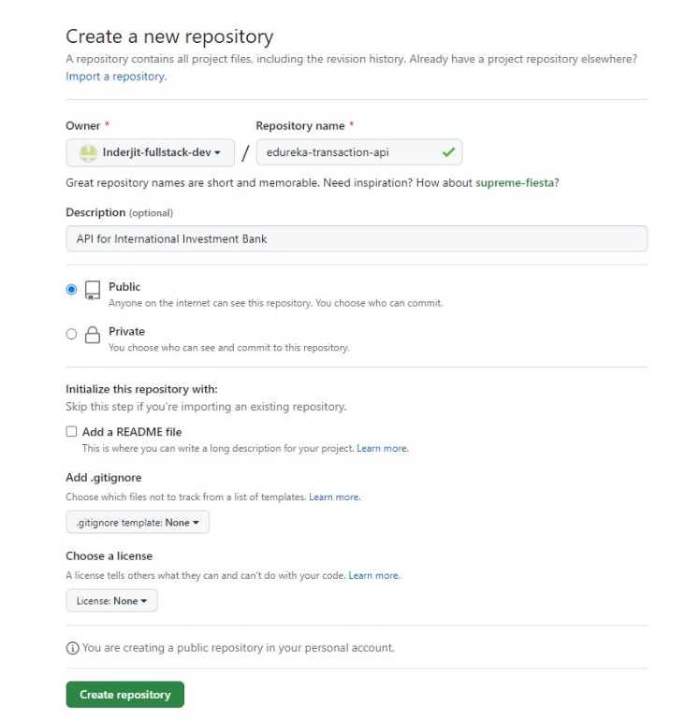

**Clone “edureka-transaction-api” repository.**

**Check the current branch.**

**Add few files.**

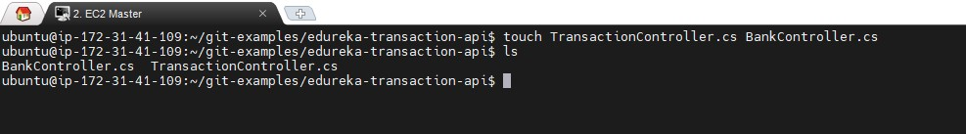

**Commit them with message.**

**Push them in branch.**

**Check last commits.**

